Monday | Tuesday | Wednesday | Thursday | Friday | Saturday | Sunday
5:00am- 9:00am | 5:00am-8:45am | 5:00am-9:00am | 5:00am-10:15am | 5:00am-9:00am | 7:00am-3:00pm*
1:00pm-1:45pm | 4:00pm- 5:00pm | 12:30pm-3:00pm | 4:00pm-5:00pm | 11:15am-3:00pm |  | 12:00pm-5:00pm
4:00pm-8:00pm |  | 4:00pm- 8:00pm |  | 4:00pm-7:00pm
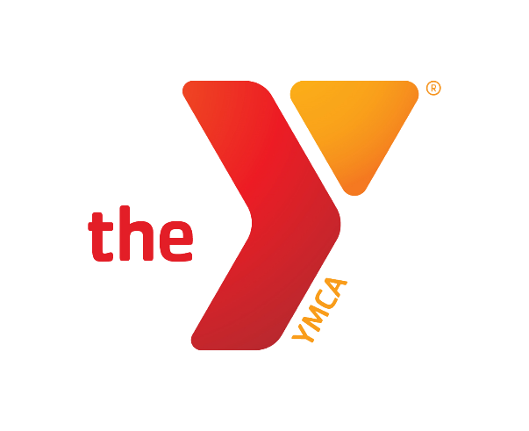
Open Basketball Court Hours
August 2023
*Saturday 8/12 Youth Basketball Games 12:00pm-3:00pm
*After School Programming 3:00pm-4:00pm Monday- Friday
*Brooks Adaptive Wellness Monday and Friday 9:00am-10:00am
*Pickleball Thursdays 1:00pm- 3:00pm

