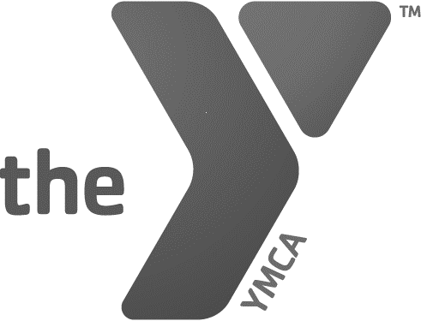
WILLIAMS FAMILY YMCA
10415 SAN JOSE BLVD. JACKSONVILLE, FL 32257
904.292.1660

JUNE & JULY POOL SCHEDULE
MONDAY |  | TUESDAY |  | WEDNESDAY
POOL HOURS  8:30-2:00PM & 4:00-7:00PM |  | POOL HOURS  8:30-7:00PM |  | POOL HOURS  8:30-2:00PM & 4:00-7:00PM
7:30-8:30AM | SWIM TEAM ONLY |  |  | 7:30-8:30AM | SWIM TEAM ONLY
8:30AM | POOL OPENS  TO MEMBERS | 8:30AM | POOL OPENS  TO MEMBERS | 8:30AM | POOL OPENS TO MEMBERS
9:00-10:00AM | AQUA FITNESS | 8:45-9:45AM | AQUA FITNESS | 9:00-10:00AM | AQUA FITNESS
10:15-2:00PM | LAP & FAMILY SWIM | 10:00-3:30PM | DAY CAMP SWIM | 10:15-2:00PM | LAP & FAMILY SWIM
11:30-12:00P | TENNIS CAMP | 11:30-12:00P | TENNIS CAMP | 11:30-12:00P | TENNIS CAMP
 |  | 12:00-7:00PM | LAP & FAMILY SWIM | 12:30-2:00PM | DAY CAMP SWIM
4:00-7:00PM | LAP & FAMILY SWIM | 5:00-7:00PM | SWIM LESSONS | 4:00-7:00PM | LAP & FAMILY SWIM
5:00-7:00PM | SWIM LESSONS |  |  | 5:00-7:00PM | SWIM LESSONS

THURSDAY |  | FRIDAY |  | SATURDAY
POOL HOURS  8:30-7:00PM |  | POOL HOURS  8:30-2:00PM & 4:00-7:00PM |  | POOL HOURS  8:00-2:00PM
8:30AM | POOL OPENS TO MEMBERS | 8:30AM | POOL OPENS  TO MEMBERS | 8:00AM | POOL OPENS TO MEMBERS
8:45-9:45AM | AQUA FITNESS | 9:00-10:00AM | AQUA FITNESS | 8:30-12:30PM | SWIM LESSONS
10:00-3:30PM | DAY CAMP SWIM | 10:15-2PM | LAP AND FAMILY SWIM | 9:00-2:00PM | LAP & FAMILY SWIM
11:30-12:00PM | TENNIS CAMP | 12:30-2:00PM | DAY CAMP SWIM | Please call to inquire if there will be any swim meets on Saturdays. On those days, pool opens at 11:30AM.
12:00-7:00PM | LAP & FAMILY SWM
5:00-7:00PM | SWIM LESSONS | 4:00-7:00PM | LAP & FAMILY | POOL IS CLOSED ON SUNDAYS
 |  | 5:00-7:00PM | Make up lessons
- Aqua Fitness requires registration on the YMCA APP.
- Pool hours subject to change based on staff availability
- During Day Camp swim, members/families/guests are permitted to be in the pool area. Note that some days, there will be numerous campers during these swim times.
UPDATED 6/19/24

