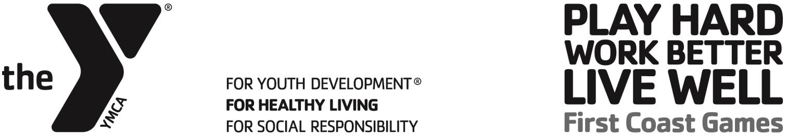

BOWLING TOURNAMENT DETAILS
Tournament: Saturday, May 2nd / Check-In at 10:00am / Bowling at 11:00am
Location: Jax Lanes
Address: 8720 Beach Blvd., Jacksonville, FL 32216
Phone: 904.641.2222
Event Director: Sean Bonday / 904.703.8750 / sbonday@fcymca.org
Event Format: (See tournament details)

TEAM ROSTER
Each team shall be composed of four players. There shall be a minimum of one female and one male on each team. A maximum of 8 players will be allowed on each roster.

TOURNAMENT DETAILS
All teams will bowl TWO games. The total pins knocked down will determine the top six teams. Six teams will advance and bowl ONE game and the highest total pins wins the event. This event will give teams the choice to choose between the Recreational Division and the Competitive Division.

LANES
The lanes will be determined prior to each game. Players will alternate lanes after each throw as they do in standard tournament structure.

UNIFORMS
All teams are required to wear the First Coast Games t-shirt that is provided.
There is no rule on the color of pants. Pants must be an appropriate length and must be worn properly. It is the tournament director’s discretion to hold a player out of a game for inappropriate uniforms.

WAIVERS
All participants must sign a First Coast Games waiver to be eligible to play.

