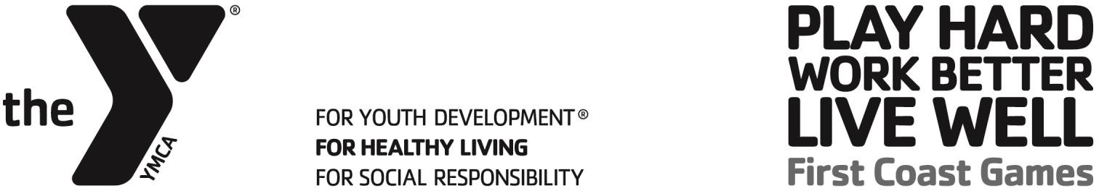

PICKLE BALL TOURNAMENT DETAILS
Tournament: Monday, May 4th – Thursday May 7th at 6:00pm
Location: Brown Family YMCA, 170 Landrum Lane, Ponte Vedra Beach, FL, 32082
Event Director: Sean Bonday / 904.703.8750 / sbonday@fcymca.org Location: Sandalwood High School, 2750 John Promenade Blvd, Jacksonville, FL, 32246
Event Director: TBD
Event Format: Competitive and Recreational Pool Play/ Single Elimination Tournament

EVENT DESCRIPTION
The Brown Family YMCA and Sandalwood High School will be this year’s hosts to the FCG Pickle Ball Tournament! Teams will face each other in three separate doubles matches.

ROSTERS
Teams will consist of at least six (6) players for each team:
- Male Doubles(2 males on one team)
- Female Doubles(2 females on one team)
- Mixed Doubles(1 male and 1 female on one team)

- 3 matches per team played at the same time
Note: All three matches will begin at the same time; therefore, a player will not be allowed to play in more than one match in a round.

*A maximum of 10 players will be allowed on a roster.

WAIVERS
All participants must sign a First Coast Games waiver to be eligible to play.

UNIFORMS
Players are encouraged to wear the First Coast Games team shirt provided.

DOUBLES TEAM PICKLE BALL RULES

GENERAL RULES
- Match time is forfeit time.
- Players will be responsible to furnish their own pickle ball paddles.
- If a player is injured and cannot continue playing, that match will be marked as retired and his/her team will lose that match.

TOURNAMENT FORMAT
A game will consist of 3 matches that will begin simultaneously.

SCORING
Each match will play best 2 out of 3. All matches will play to 11, win by 2. After the best 2 out of 3 is played for each match – whoever won those matches 2 out of 3 wins the game.

